**BCSE204P- Design and Analysis of Algorithms Lab**

**E1-Slot-L43-L44 Lab**

**In-Lab Practice (IPS) Exercise-2**

**Name: R. Muhmmad Abrar**

**Register no: 21BRS1713**

**Any Three question Output:**

**Q2).**

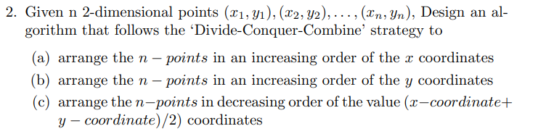



**Code:**

**Output:**

**Q3).**

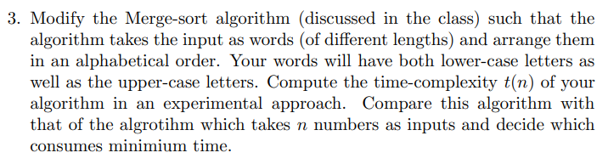

**Code:**

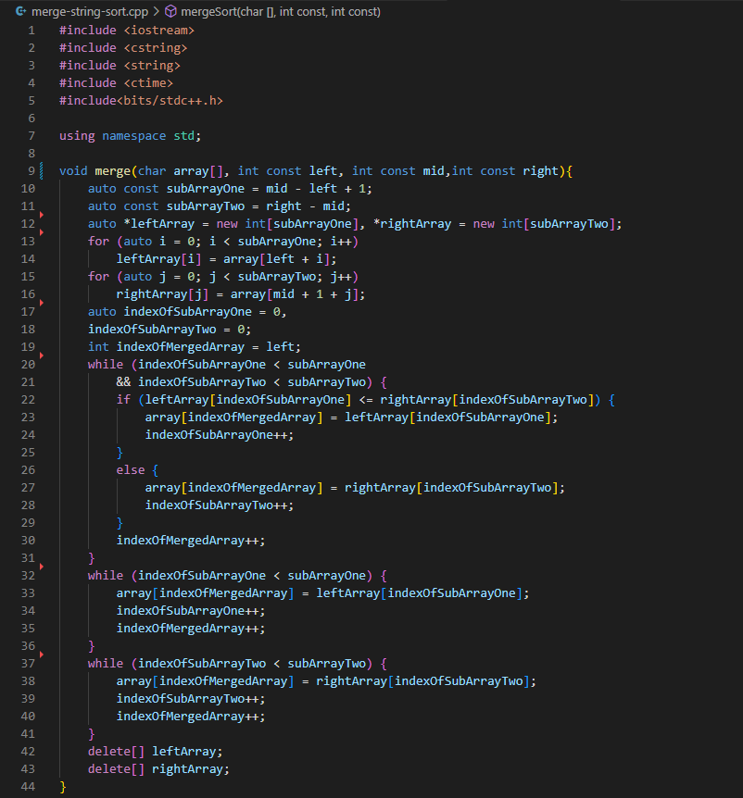

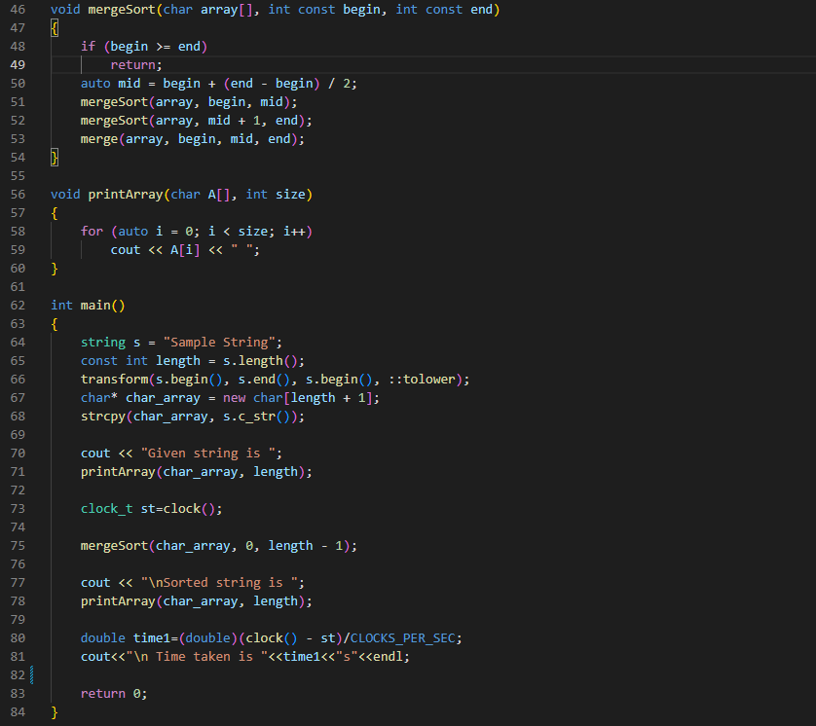

**Output:**

**Q8).**

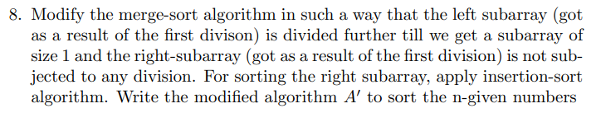

**Code:**

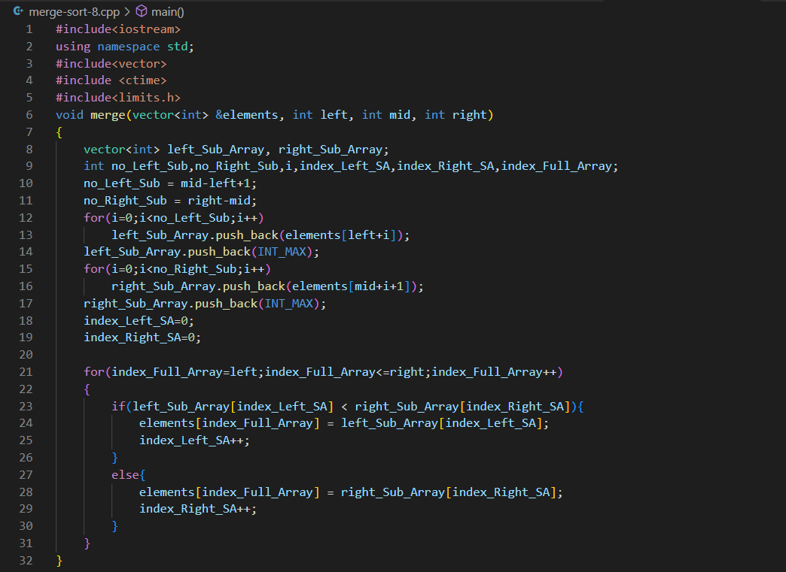

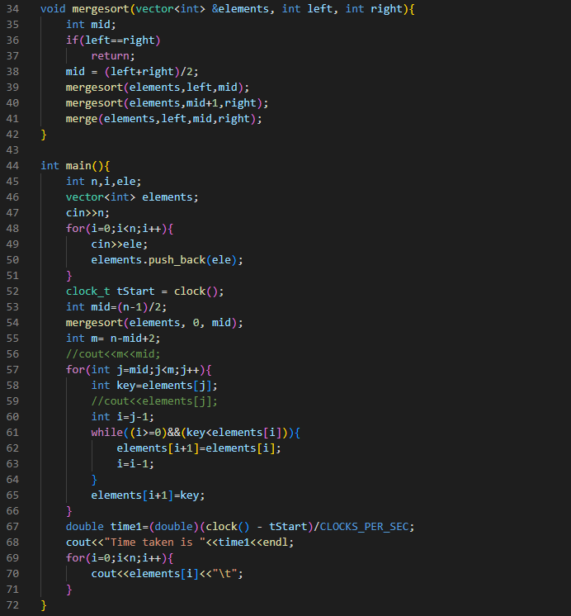

**Output:**